1、955T图片
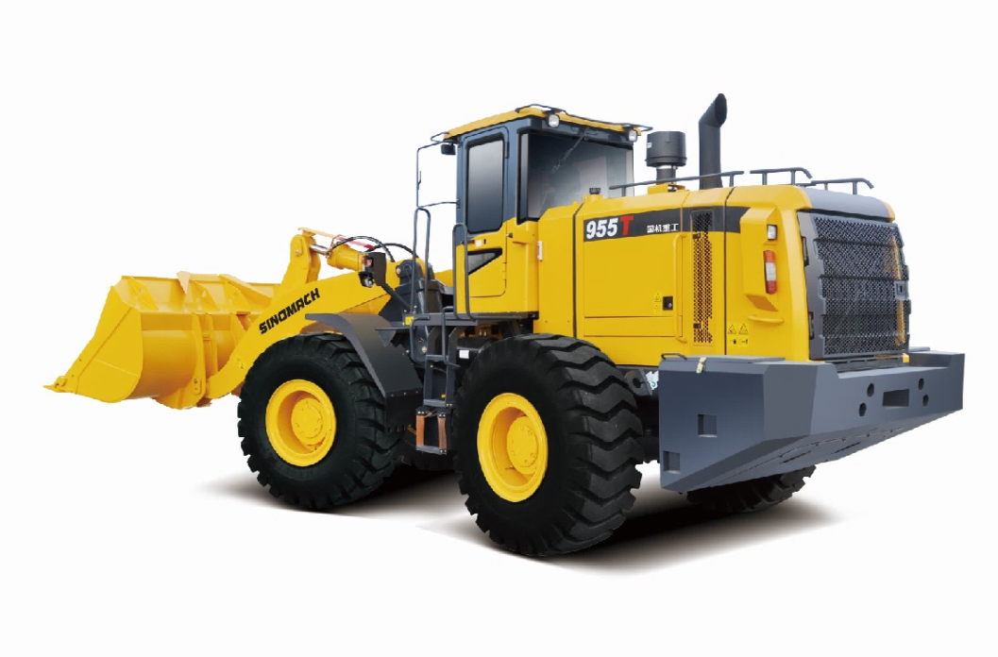
2、955T性能参数 Specification
- Overall Dimension 总尺寸
1 | Length(with bucket on ground)总长（铲斗放置地面）* | 8020(mm)
2 | Width(to outside of wheels)总宽（到轮胎外沿） | 2800(mm)
3 | Bucket width铲斗宽度* | 2946(mm)
4 | Height(To the top of the cab)高度（到驾驶室顶）* | 3450(mm)
5 | Wheel base轴距 | 3100(mm)
6 | Min. ground clearance最小离地间隙 | 450(mm)
- Technical Specification性能参数
1 | Rated load额定载重量 | 5000(Kg)
2 | Operating weight操作重量 | 16500KG
3 | Rated bucket capacity额定斗容 | 2.8(m³)，可选2.2-4.5 (m³)
4 | Max. dump clearance最大卸载高度 | 3136(mm)
5 | Dump reach卸载距离 | 1171(mm)
6 | Min. turning radius(wheel)轮胎外最小转弯半径 | 5970(mm)
- Diesel engine发动机
1 | Model型号 | WeiChai 潍柴 WD10G220E23
2 | Type形式 | Direct injection. 直喷
3 | Rated output额定功率 | 162 (kW)
5 | Total exhaust of cylinder排气量 | 9.726(L)
9 | Rated speed额定转速 | 2000(r/min)
10 | Max. Torque最大扭矩 | 900(N.M)@1400 r/min
- Transmission System传动系统
1 | Model型号 | HANGCHI杭齿 ZL50D-023
2 | Type形式 | 4-elements.single stage  单级四元件
3 | Gear shift position档位 | 2F、 1 R前二后一档位
4 | Speed 速度（F/R） | 11.7/15.9，40.3
5 | Max. drawing force最大牵引力 | 170kN
6 | Size of tire轮胎型号 | 23.5-25-16PR
- Working Hydraulic System工作液压系统
1 | Model of oil pump工作油泵型号 | JHP 3100A
2 | System pressure系统压力 | 18MPa
3 | Model of Muti-way directional valve 多路阀型号 | GDF32Ⅱ-YL18
5 | Pilot valve先导阀型号 | 无（选配）
- Steering System转向系统
1 | Model of steering pump转向泵型号 | JHP2080S
2 | Model of redirector 转向器型号 | TLF2-E800B+FKBR3022
3 | Model of priority valve 优先阀 | YXL-F250F-N7
4 | System pressure转向系统压力 | 16MPa
- Brake System制动系统
1 | Type of traveling brake 行车制动形式 | Caliper disc brake钳盘式制动器
2 | Air pressure制动气压 | 6-7.5(kgf/cm²)
3 | Type of parking brake停车制动形式 | Clamp brake鼓式制动
- Oil Capacity加油量
1 | Fuel(diesel)燃油 | 280(L)
2 | Engine lubricating oil机油 | 24(L)
3 | Oil for converter and gear box变速箱油 | 45(L)
4 | Oil for hydraulic system液压系统油 | 245（L)
5 | Oil for driving axles（F/R）前后驱动桥油 | 18/18(L)

